Virgina screen shot

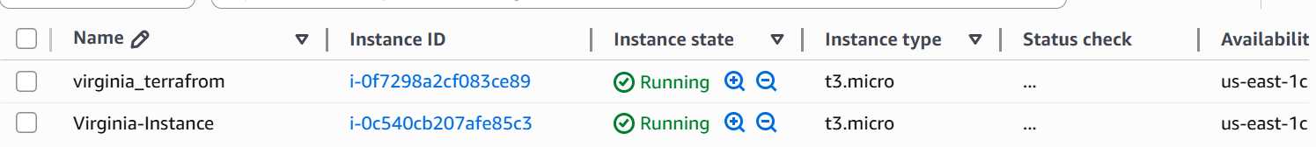

Terraform name Virginia-Instance

Mumbai screen shot

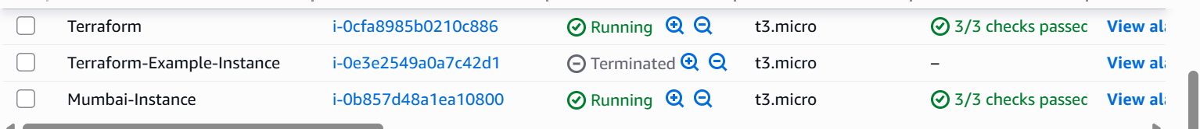

Terraform Name Mumbai- Instance

